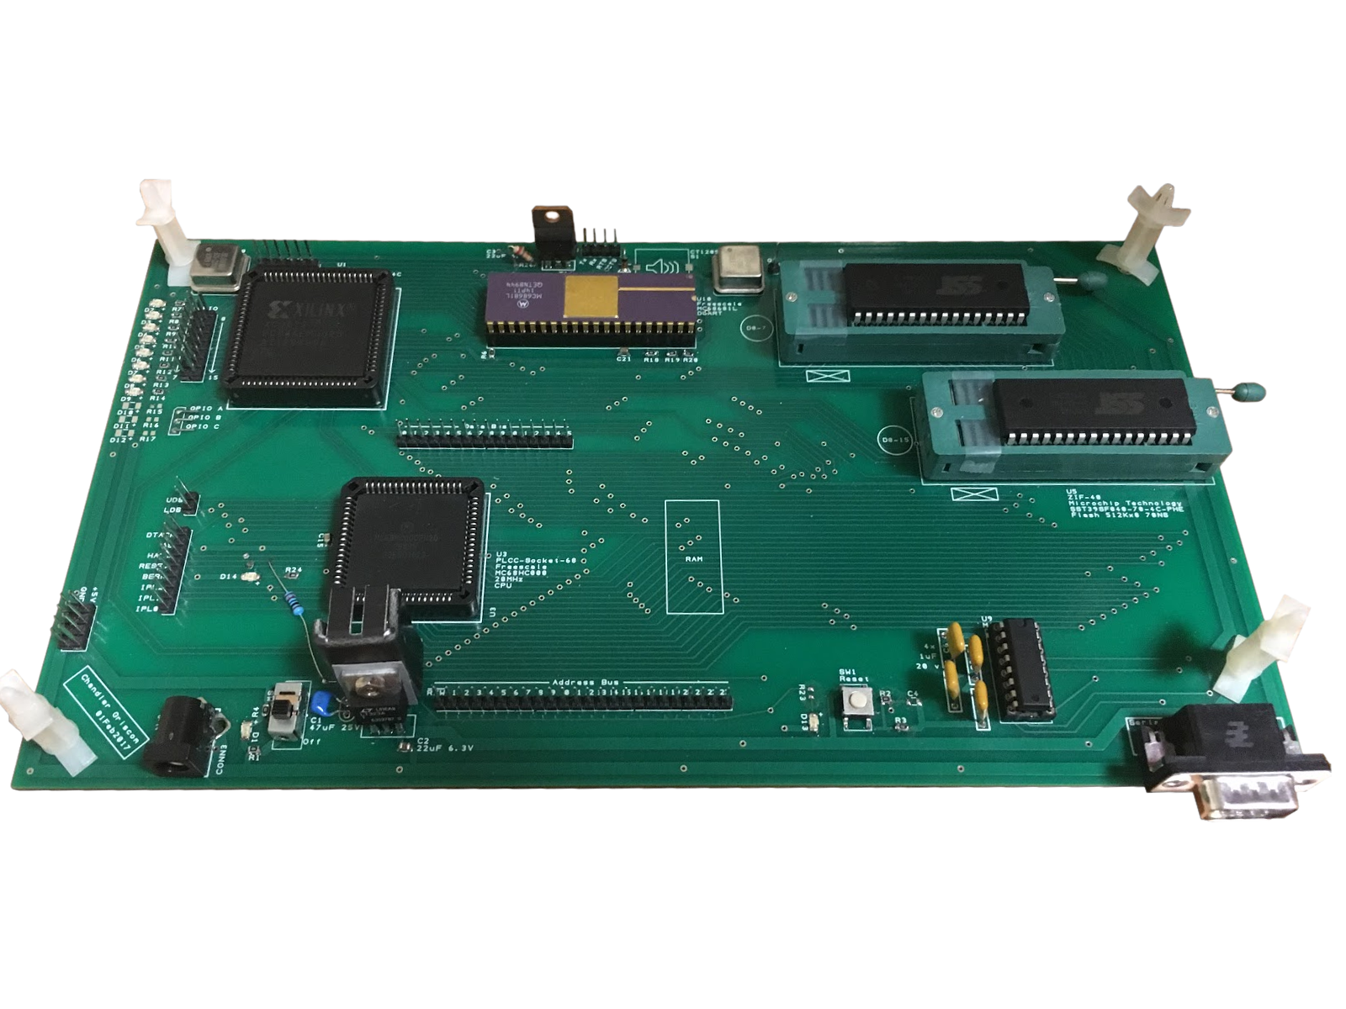

Microcomputer Design
Final Report

Presented to

Chandler Griscom
chandlergriscom@letu.edu

Presented to

Dr. Joonwan Kim
EEGR 4253
23 Apr 2017

Table of Contents

I. Description of Project 3

II. Hardware Description 4
1. Introduction 4
2. Block Diagram 5
3. Specifications 6
4. Technical Schematics 6
5. Price Figures 9
6. Time Figures 10

III. Software Description 11
1. Introduction 11
2. Memory Mapping and Interrupt Details 11
3. Core Functionality 12
4. Flowcharts 13

IV. Troubleshooting 14
1. Hardware Issues 14
2. Software Issues 14

Appendix 15
1. Copy-to-ROM Routine 15
2. Monitor Program Code Listing 16

I. Description of Project

Motorola 68000 Single-Board Computer Project

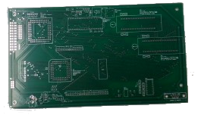
This project was designed and built for EEGR4253 – Microcomputer Design. In that course, students are required to design from scratch and build a working computer with the following minimum hardware requirements:

- An RS-232 compatible data port capable of operating at 19,200 baud
- 64K of RAM (random access memory)
- The capability of addressing 64K of memory space.
- An “on-board” monitor program residing in EPROM, EEPROM, or any non-volatile memory.

Additionally, the computer is required to support the following software operations:

- Examining the contents of any memory location within the memory space
- Changing the contents of any random access memory location within the memory space
- Examining and changing the contents of all CPU registers
- Transmitting and receiving data via all data ports
- Allowing a machine-coded program to be loaded into RAM from a data port
- Executing a program that has been loaded into RAM

This project was completed by Chandler Griscom over the course of Spring 2017 semester at LeTourneau University. Skills acquired as a result of completing the project include:
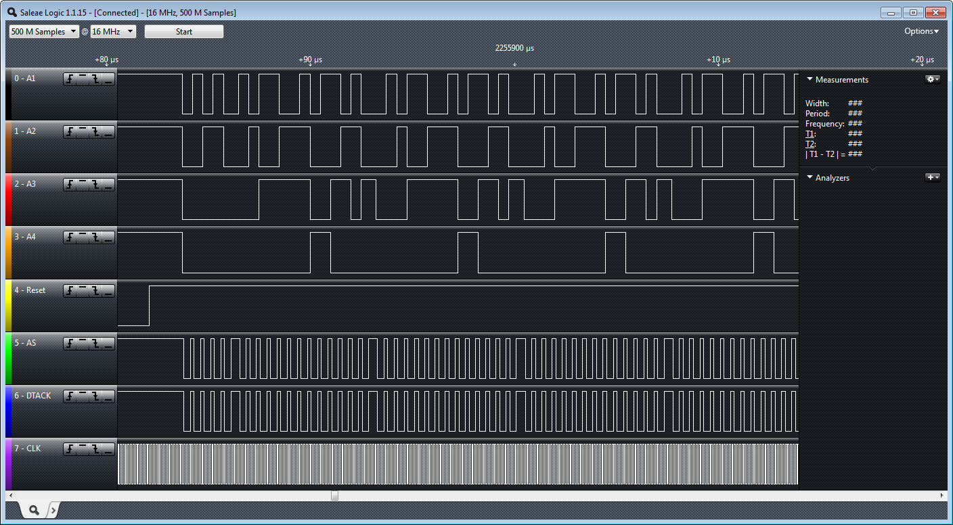
- Implementing logical constructs using a Xilinx CPLD and VHDL

- Programming in 68k assembly language

- Debugging hardware with a logic analyzer

- Understanding of the low-level hardware organization of a computer

- Understanding of basic operating system concepts

The remainder of this report is broken up into four sections: hardware details, software details, troubleshooting accounts, and an appendix containing assembly code listings.
II. Hardware Description

1. Introduction

The hardware selection and design decisions for this 68k single board computer were made based on recommended parts, availability of obsolete components, pricing, and prospects of future usage. In addition to the core project requirements, the following components and connections were deemed useful:
- Both RS232-compatible and TTL (i.e. Arduino) compatible serial ports
- Writable flash memory that doubles as ROM – should be editable without lab equipment
- Interrupt lines for implementing a timer (needed for preemptive scheduling and possibly for writing to flash memory)
- A dividable clock (80 MHz may be divided into 8, 10, or 20 MHz)
- A buzzer/speaker driver (these parts were never ordered but there is space on the board)
- ZIF, DIP, and PLCC sockets for easily switching out components (especially flash chips)

Much of the necessary research was able to be postponed by routing “unknown” connections to the XC9572 CPLD and then later internally mapping these connections using VHDL code.
The PCBArtist application was used to design the 2-layer circuit board for the project. All component datasheets were analyzed and drawn up in the software. A schematic of the electrical connections was created and then translated to a printed circuit board layout by manually orienting components and drawing copper traces.
The finished circuit board design was ordered from 4pcb under their student discount.

2. Block Diagram
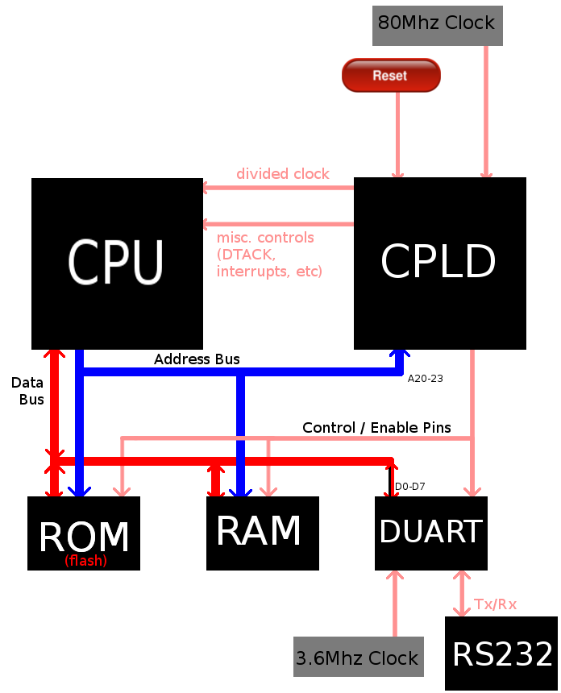

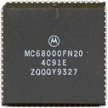
3. Technical Specifications

- Motorola 68000 Processor – Clocked at 20MHz (Freescale MC68HC000FN20)
- ½ MB Static RAM (Alliance Memory AS7C4098A-12JIN)
- 1 MB Flash Memory (2x Microchip Technology SST39SF040-70-4C)
- 16 general purpose buffered I/O pins (including 8 LEDs)
- DUART: 2 serial ports at 19200 baud rate (Motorola MC68681L)
  - Port A: RS232-compatible (10 V), (driven by Texas Instruments MAX232EIN)
  - Port B: TTL-compatible (5 V)
- CPLD providing a 1 ms timer, glue logic, interrupt generators (Xilinx XC9572-7PC84C)
- 10.5” x 5.5” 2-layer PCB (ordered from 4pcb)

4. Schematics
a. CPU Connections

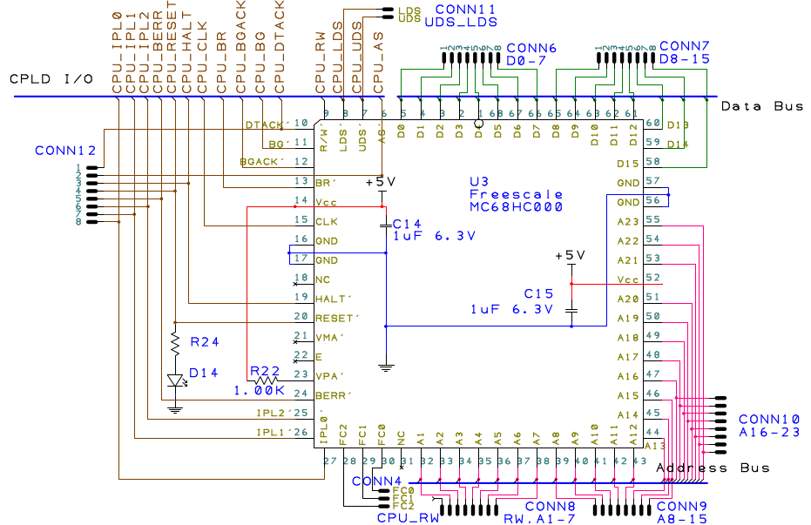

b. CPLD Connections
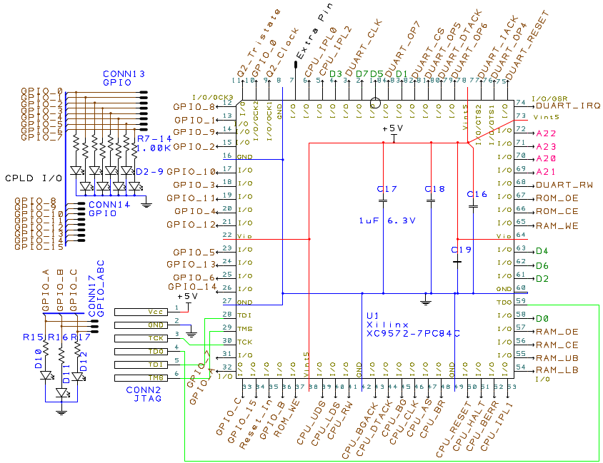
c. DUART Connections
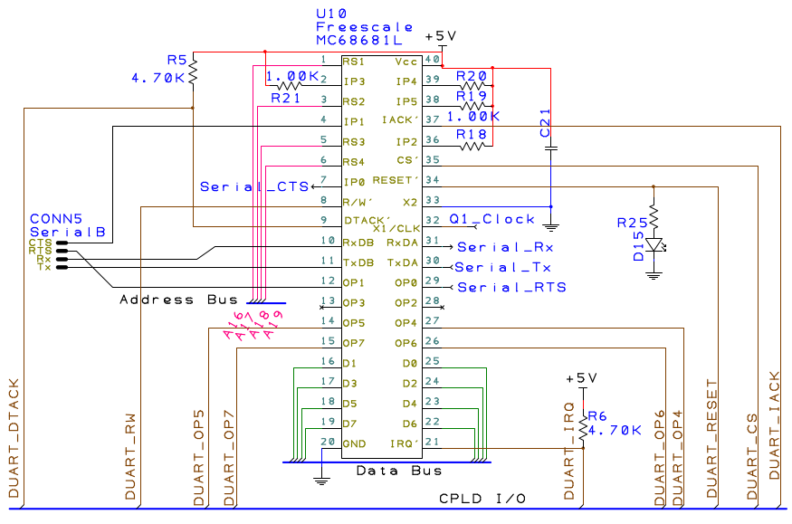

d. ROM Connections  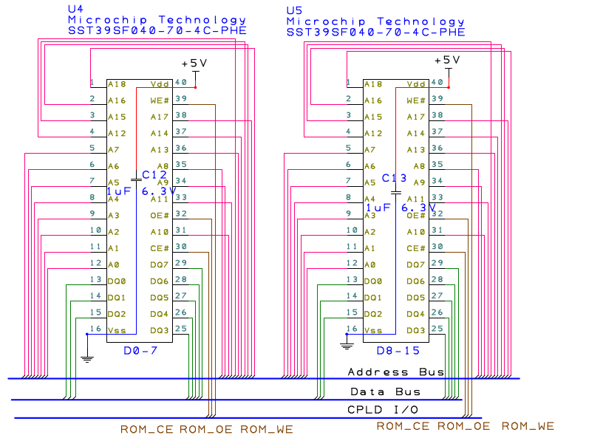 | e. RAM Connections  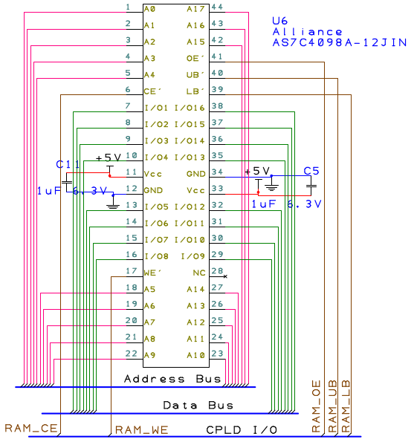

f. Miscellaneous Connections

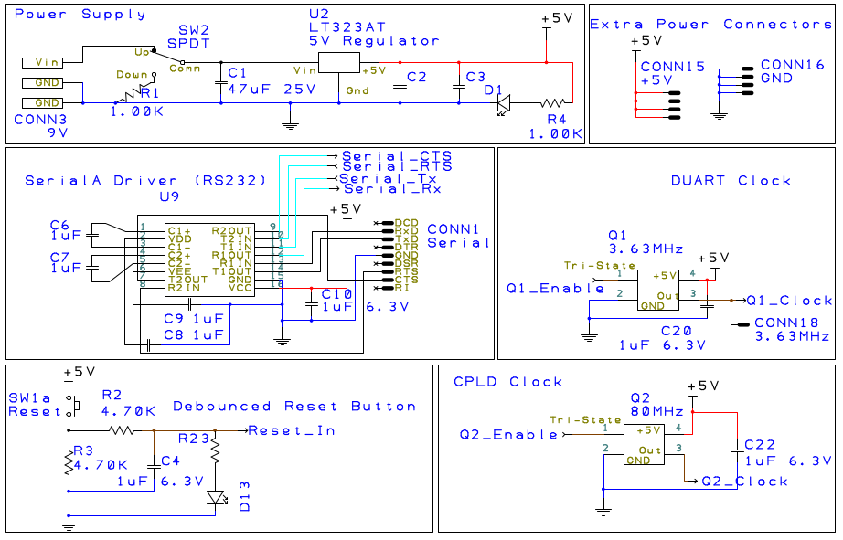

g. PCB Layout (PCB Artist Export)
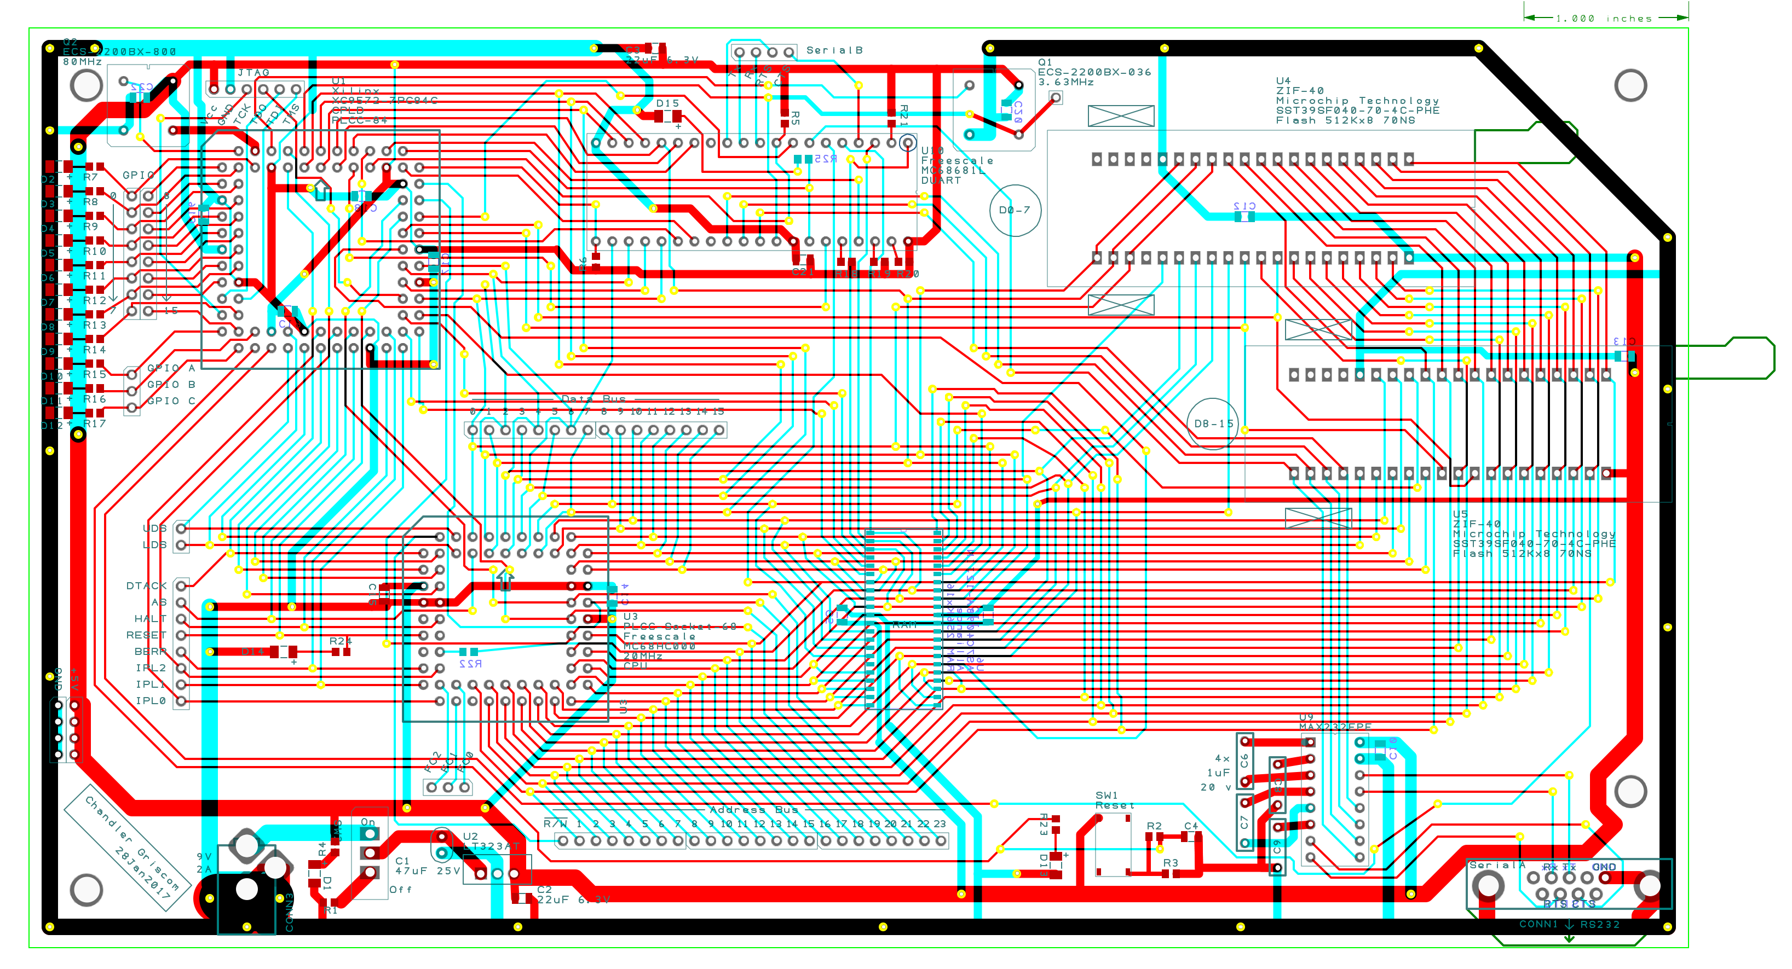

5. Price Figures
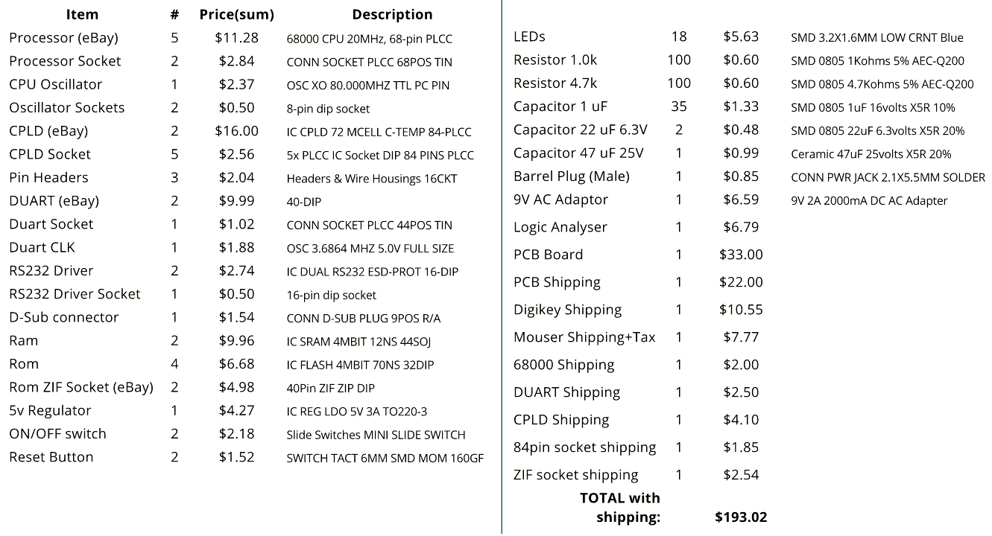

6. Time Figures

III. Software Description

1. Introduction
The software for the 68000 single board computer is comprised of a Monitor Program (essentially a simple operating system), a loadable ROM burner program, and uploadable S records (ASCII-encoded machine code). It was developed incrementally by first implementing an S-record “bootloader” which allowed complex programs to be tested in RAM, then creating a ROM burner program that could overwrite the bootloader, and finally the Monitor Program itself. This incremental development was done so that most of the testing could be done outside of the Microcomputer Design lab once the S record routines were functioning.
I used the software portion of the project to test out some concepts that had been studying for COSC3503 – Operating Systems. The interrupt handling, DUART buffering, and ROM management subsystems were all motivated and inspired by topics from that course. Although they were not required for Microcomputer Design, they provided experience that supplemented my learning in both classes.

2. Memory Mapping and Interrupt Details

a. Memory Space Organization

b. Interrupt Levels and Vectors

3. Core Functionality
Externally, the monitor program is organized as a pair of menus in which options are selected by sending ASCII characters through the serial terminal. It can perform the following operations:

- Examine and change the contents of any memory location within the memory space
- Print a 16x16 table of memory locations and values
- Examine and change the contents of any of the CPU’s internal registers
- Allow a S record-encoded program to be loaded into RAM and executed from the serial port (hidden, for testing purposes)
- Allow an S record to be copied to ROM and later loaded into RAM for execution
- Manage settings such as interrupt usage and the LED timer
- ROM Burning features:
  - Copy one flash ROM chip to another
  - Allow hotswapping chips by temporarily pausing the CPU and DUART
  - Erase the entire flash contents and upload a new S record (i.e. overwrite the monitor program)

Internally, the monitor program is comprised of 6 interacting components.
- Interrupt handlers
- Menu system
- ASCII and S record parsing routines
- S record loading routines (ROM and RAM variants)
- A loadable ROM burner S record (executes in RAM)
- A loadable “Copy RAM Buffer to ROM” routine

4. Flowcharts
a. Monitor Program
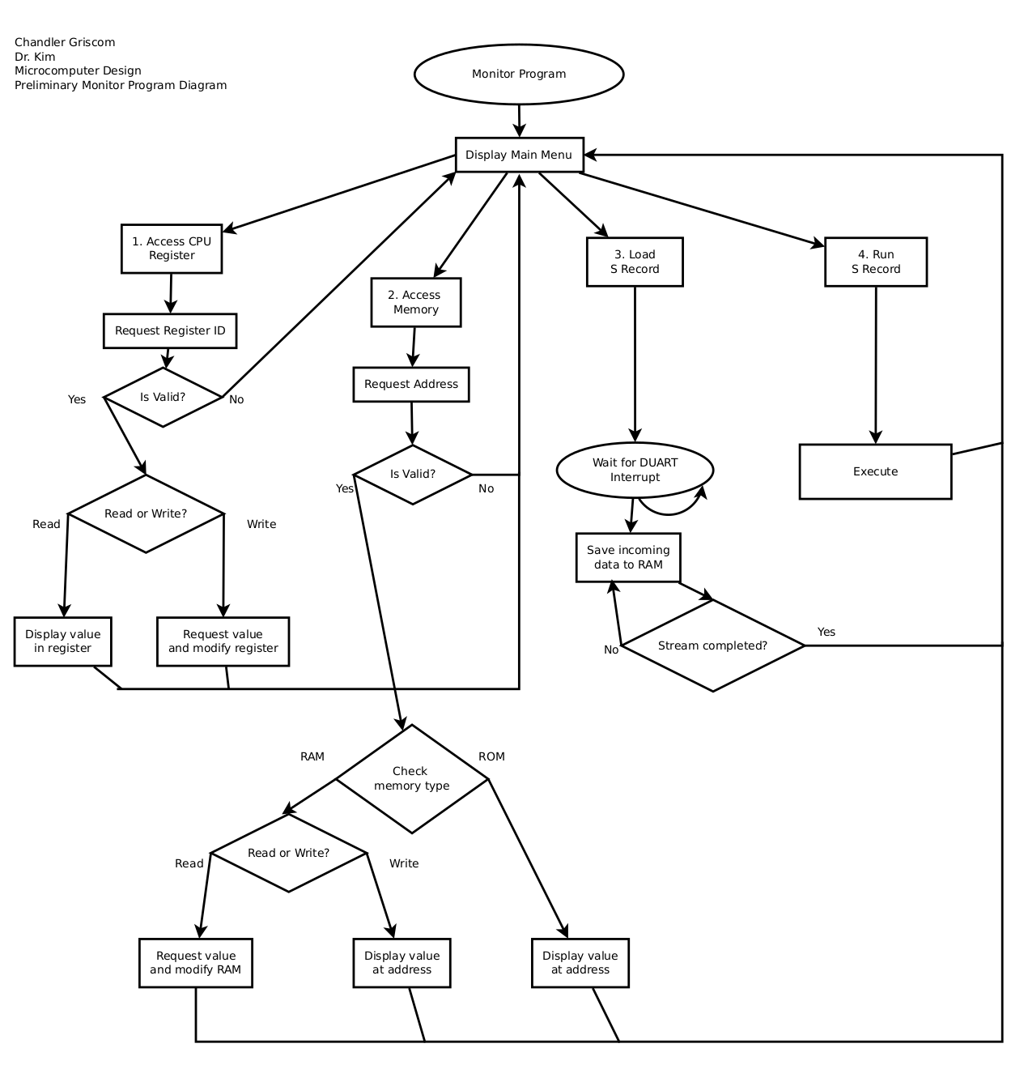

b. ROM Upload Subsystem
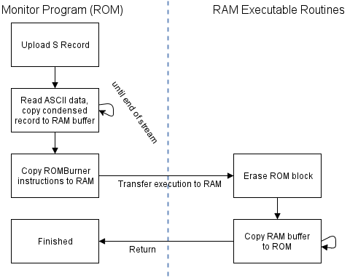
IV. Troubleshooting

1. Hardware Issues
The first issue encountered involved the HALT and RESET pins of the CPU. My schematic treated them as if they were typical inputs, but the datasheet specifies that they may be used as inputs or outputs depending on bus control parameters. If the CPU ever decides to halt itself, inconsistent states / shorts can occur if the CPLD is trying to force HALT or RESET against the CPU output. To fix this I changed the CPLD behavior to treat these two pins as either high-impedance or '0' (active-low) and then added two 4.7K resistors to pull them high by default.
The next notable issue involved a simple misunderstanding on my part; I did not realize that the function code outputs of the CPU were necessary for interrupt acknowledgments and accidentally left them disconnected from the CPLD. Luckily I had exactly three extra CPLD pins and managed to tie FC0, FC1, and FC2 to those pins using jumper wires.
Later on in the project I encountered an issue with one of the PLCC sockets; a single pin connecting the CPLD to the ROM's R/W line became intermittently connected; sometimes it would function as normal, sometimes it wouldn't work at all (preventing the ROM burner from working), and sometimes it would work if I flexed the board. I eventually solved the issue by cleaning the CPLD socket and bending all of the pins out a bit to achieve a better connection.

2. Software Issues
The most evasive and confusing issue I encountered was a simple VHDL mistake; I forgot to tie the unused BGACK (bus arbitration acknowledgement) pin high. The board experienced issues where the CPU would run a ROM test for about 100ms, then “slow down” (miss clock cycles) and halt itself. Blowing air on a certain area of the board would keep it running for a longer time, leading me to believe it was an issue with overheating. I eventually figured out that it was caused by the indeterminate state of that one input pin.
The counter-intuitive nature of the 68k's data bus caused some issues with the DUART code initially; even addresses use the high byte (D8-15) and odd ones use the low byte (D0-7). My hardware configuration connected the DUART to the low byte, and I did not realize at first that all the DUART register addresses must be odd.

5. Appendix

1. Copy-to-ROM Routine (included as a loadable machine code listing at the end of Monitor Program)
*-----------------------------------------------------------
* Title : Copy RAM Buffer to ROM
* Written by : Chandler Griscom
* Description : This short subroutine is uploaded to RAM by
* the monitor program to perform ROM-writing
tasks (because ROM is useless to the CPU
during write operations)
*-----------------------------------------------------------
N_CONFIRMS EQU 2 ; How many times should the toggle bit be verified?

ORG $17F000 ; Location at which this routine is moved into RAM
; ******** Calling parameters **********
; D6: Toggle bit status
; A0: RAM (Source) Start Address
; A1: ROM (Dest) Start Address
; A2: RAM (Source) End Address
; begin program
COPYRR_MAIN
BSR ERASE_SECT ; Erase initial sector
COPYRR_LOOP MOVE.B (A0)+, D1 ; Move data into position for copying
BSR WRITE_BYTE ; Write
LEA 1(A1), A1 ; Increment A1
; TODO further erases

CMP.L A0, A2 ; If start != end,
BNE COPYRR_LOOP ; then continue
RTS

* Subroutine ROM_PRES_B
* Keys the 2-cycle software control codes into both rom chips
ROM_PRES_B MOVE.W #$AAAA, $00AAAA
MOVE.W #$5555, $005554
RTS

ERASE_SECT
BSR ROM_PRES_B
MOVE.W #$8080, $00AAAA ;Erase sector pt1
BSR ROM_PRES_B
MOVE.W #$3030, (A1) ;Erase sector pt2
BSR CP_toggle Wait until erased
;ADDI #1, A1 ; High-toggling byte TODO might not need to toggle both chips
;BSR CP_toggle Wait until erased
;SUBI #1, A1 ; Restore A1
RTS

; Sub: Wait for toggle indicator bit to stop toggling on hi ROM
; A6: the address to be checked
CP_toggle MOVE.B #1, D4 Clear D4 (ROL status)
MOVE.B (A1), D1 Read toggle bit to D1
CP_toggle2
BTST #N_CONFIRMS, D4 Test bit for N confirms
BNE CP_tog_RET If that bit is high, confirmation succeeded 3 times
MOVE.B D1, D2 Save previous toggle bit
MOVE.B (A1), D1 Read new toggle bit to D1
EOR.B D1, D2 EOR new byte onto old one
BTST #6, D2 If EOR indicates the byts are different (toggle bit6 = 1)
BNE CP_toggle2 If same (0), continue. If different (1), start over
ROL.B #1, D4 Rotate D4 bit (same)
BRA CP_toggle2 Return
CP_tog_RET RTS
;----- End Copy Routine -----;

* Subroutine WRITE_BYTE
* D1: Data Byte
* A1: Address for write
* D3: Reserved
WRITE_BYTE
MOVE.L A1, D3
BTST #0, D3
BNE WRITE_ODD If set (1), go to odd

;Even/High
WRITE_EVEN BSR ROM_PRES_B
MOVE.W #$A000, $00AAAA ;Erase High pt2;Write pt 1
MOVE.B D1, (A1) ; Write byte
;MOVE.B D1, LED ; debug
BSR CP_toggle
RTS

;Odd/Low
WRITE_ODD BSR ROM_PRES_B
MOVE.W #$00A0, $00AAAA ;Erase High pt2;Write pt 1
MOVE.B D1, (A1) ; Write byte
;MOVE.B D1, LED ; debug
BSR CP_toggle
RTS

END COPYRR_MAIN

2. Monitor Program Code Listing
*-----------------------------------------------------------
* Title : Monitor Program
* Written by : Chandler Griscom
*-----------------------------------------------------------

SIM EQU 0 ;0 = hardware state, 1 = simulation state

BUFFER_A_SP EQU $104000 ;DUART circular buffer
BUFFER_A_EP EQU $104004
BUFFER_A_S EQU $104008
BUFFER_A_E EQU $104200

BUFFER_R_S EQU $110004 ; Use to buffer data into RAM before copying to ROM
BUFFER_R_P EQU $110000

COPYRR_MAIN EQU $17F000 ; Location of copy ROM routine

ROMBurn_ROM EQU $006000 ; Location of ROMBurner program
USR1_ROM EQU $008000 ; Location of User Program 1

SUPER_STACK EQU $103F00
TIMER_SEC EQU $103F04
TIMER_MS EQU $103F08
DUINT_DISABLE EQU $103F10 ; Interrupts disabled? -> #$00
ECHO_MEM EQU $103F11 ; Echo On -> #$FF
TIMER_MEM EQU $103F12 ; Timer LEDs On -> #$FF

CPLD_STATUS EQU $300001

LED EQU $F00001

MR1A EQU $200001 Mode Register1
MR2A EQU $200001 points here after MR1A is set
SRA EQU $210001 Status Register (read)
CSRA EQU $210001 Clock Select Register
CRA EQU $220001 Command Register
TBA EQU $230001 Transfer Holding Register
RBA EQU $230001 Receive Holding Register
ACR EQU $240001 Auxiliary control register

MR1B EQU $280001 Mode Register1
MR2B EQU $280001 points here after MR1A is set
SRB EQU $290001 Status Register (read)
CSRB EQU $290001 Clock Select Register
CRB EQU $2A0001 Command Register
TBB EQU $2B0001 Transfer Holding Register
RBB EQU $2B0001 Receive Holding Register

IMR EQU $250001 Interrupt Mask Register
ICR EQU $250001 Interrupt control register
IVR EQU $2C0001 Interrupt vector register

RxRDY EQU 0 Recieve ready bit position
TxRDY EQU 2 Transmit ready bit position
BAUD EQU $CC baud rate value = 19200 baud

CR EQU $0D
LF EQU $0A

START ORG $000000
DC.L SUPER_STACK Initial Stack Pointer
DC.L MAIN Initial PC
DC.L EXCEPTION Berr
DC.L EXCEPTION Address Error
DC.L EXCEPTION Illegal Instruction
DC.L EXCEPTION Div by zero

ORG $000100 Interrupt vectors
DC.L $112000 64: Should be GPIO IRQ
DC.L IPL6 65: Periodic timer interrupt
DC.L DUART_IRQ 66: DUART RxRDYA or RXRDYB

; TIMER INTERRUPT HANDLER
ORG $000400
IPL6 MOVE.L D0, -(SP)
MOVE.W TIMER_MS, D0
ADD.W #$1, D0
MOVE.W D0, TIMER_MS
CMPI.W #$03E7,D0
BLS.S IRQ6_QUIT
CLR.W TIMER_MS
MOVE.L TIMER_SEC, D0
ADD.L #$1, D0
MOVE.L D0, TIMER_SEC

CMP.B #$FF, TIMER_MEM If timer off,
BNE IRQ6_QUIT quit
MOVE.B D0, LED ; Else display the timer LED

IRQ6_QUIT MOVE.L (SP)+, D0
RTE

; DUART Interrupt Handler

DUART_IRQ OR.W #$0700, SR ; Mask all interrupts
MOVE.L D0,-(SP)
MOVE.L A0,-(SP)
TestA

MOVE.B SRA, D0 Read the A status register
BTST #RxRDY, D0 Test reciever A ready status
BEQ TestB Goto B if no character in buffer
MOVE.B RBA, D0 Else, Read the character into D0

; Circular queue write A
MOVE.L BUFFER_A_EP, A0 Load the end pointer
MOVE.B D0, (A0)+ Insert the read byte
CMP.L #BUFFER_A_E, A0 If not at end of buffer,
BNE BUFFER_A_WF Branch to finish
MOVE.L #BUFFER_A_S, A0 Move end pointer to beginning of buffer
BUFFER_A_WF MOVE.L A0, BUFFER_A_EP

CMP.B #$FF, ECHO_MEM If echo off,
BNE TestA Flush buffer
JSr PUTCHAR_A Else putchar

BRA TestA Flush buffer again (if nothing exists it will branch to TestB)
TestB

DU_Ret MOVE.L (SP)+, A0
MOVE.L (SP)+, D0
AND.W #$F8FF, SR ; TODO this line is not necessary (?) because RTE pops SR
RTE Return from exception

EXCEPTION LEA SUPER_STACK, SP ; Handle exception and reset
MOVE.L #EXPSTRING, A0
JSR PUTSTR_A
JMP MAIN

; ***Begin program***
MAIN

; Init buffers
MOVE.L #BUFFER_A_S, BUFFER_A_SP
MOVE.L #BUFFER_A_S, BUFFER_A_EP

; ROM buffer is initialized by the ROM routine

CLR.L TIMER_MS
CLR.L TIMER_SEC

JSR INIT_DUART

MOVE.B #$00, ECHO_MEM ; Turn off echo A
MOVE.B #$FF, TIMER_MEM ; Turn on timer LED

JSR ENABLE_I ;Enable all interrupts

mLOOP MOVE.L #MoniPrompt, A0 ; MAIN MENU
JSR PUTSTR_A
mgetLOOP JSR GETCHAR_A
CMP.B #'a', D0 If user says 'a', administration menu
BEQ aLOOP
CMP.B #'c', D0 If user says 'c', view registers
BEQ view_REG
CMP.B #'C', D0 If user says 'C', edit registers
BEQ edit_REG
CMP.B #'m', D0 If user says 'm', view memory range
BEQ view_MEM
CMP.B #'M', D0 If user says 'm', edit memory
BEQ edit_MEM
CMP.B #'S', D0 If user says 'S', upload userprog 1
BEQ upload_USR1
CMP.B #'x', D0 If user says 'x', execute userprog 1
BEQ exec_USR1
CMP.B #'s', D0 If user says 's', load and execute s record in RAM
BEQ S_REC_RAM
CMP.B #'r', D0 If user says 'r', refresh
BEQ mLOOP
BRA mgetLOOP

aLOOP MOVE.L #AdminPrompt, A0 ; ADMINISTRATION
JSR PUTSTR_A
agetLOOP JSR GETCHAR_A
CMP.B #'A', D0 If user says 'A', main menu
BEQ mLOOP
CMP.B #'b', D0 If user says 'b', execute ROMBurner
BEQ exec_ROMB
CMP.B #'B', D0 If user says 'B', write ROMBurner
BEQ upload_ROMB
CMP.B #'i', D0 If user says 'i', disable interrupts
BEQ sDISABLE_I
CMP.B #'I', D0 If user says 'I', enable interrupts
BEQ sENABLE_I
CMP.B #'t', D0 If user says 't', disable timer
BEQ sDISABLE_T
CMP.B #'T', D0 If user says 'T', enable timer
BEQ sENABLE_T
CMP.B #'r', D0 If user says 'r', refresh
BEQ aLOOP
BRA agetLOOP

edit_REG LEA RegPrompt, A0 ; Clear the screen
JSR PUTSTR_A
JSR GETCHAR_A ; Read register ID into D0
JSR REG_sel
JSR SCANLADD_A ; Read address into A0
BCS viewMem_RET ; Error, return
ERegD0 CMP.B #'0', D0
BNE ERegD1
MOVE.L A0, D0
BRA viewMem_RET ; Return
ERegD1 CMP.B #'1', D0
BNE ERegD2
MOVE.L A0, D1
BRA viewMem_RET ; Return
ERegD2 CMP.B #'2', D0
BNE ERegD3
MOVE.L A0, D2
BRA viewMem_RET ; Return
ERegD3 CMP.B #'3', D0
BNE ERegD4
MOVE.L A0, D3
BRA viewMem_RET ; Return
ERegD4 CMP.B #'4', D0
BNE ERegD5
MOVE.L A0, D4
BRA viewMem_RET ; Return
ERegD5 CMP.B #'5', D0
BNE ERegD6
MOVE.L A0, D5
BRA viewMem_RET ; Return
ERegD6 CMP.B #'6', D0
BNE ERegD7
MOVE.L A0, D6
BRA viewMem_RET ; Return
ERegD7 CMP.B #'7', D0
BNE ERegA0
MOVE.L A0, D7
BRA viewMem_RET ; Return
ERegA0 CMP.B #')', D0
BNE ERegA1
MOVE.L A0, A0
BRA viewMem_RET ; Return
ERegA1 CMP.B #'!', D0
BNE ERegA2
MOVE.L A0, A1
BRA viewMem_RET ; Return
ERegA2 CMP.B #'@', D0
BNE ERegA3
MOVE.L A0, A2
BRA viewMem_RET ; Return
ERegA3 CMP.B #'#', D0
BNE ERegA4
MOVE.L A0, A3
BRA viewMem_RET ; Return
ERegA4 CMP.B #'$', D0
BNE ERegA5
MOVE.L A0, A4
BRA viewMem_RET ; Return
ERegA5 CMP.B #'%', D0
BNE ERegA6
MOVE.L A0, A5
BRA viewMem_RET ; Return
ERegA6 CMP.B #'^', D0
BNE ERegA7
MOVE.L A0, A6
BRA viewMem_RET ; Return
ERegA7 CMP.B #'&', D0
BNE ERegErr
MOVE.L A0, A7
BRA viewMem_RET ; Return
ERegErr LEA RegError, A0
JSR PUTSTR_A
BRA viewMem_RET ; Error

; View Registers
view_REG LEA RegPrompt, A0 ; Clear the screen
JSR PUTSTR_A
JSR GETCHAR_A ; Read register ID into D0
JSR REG_sel
VRegD0 CMP.B #'0', D0
BEQ VReg_Print
VRegD1 MOVE.L D1, A0
CMP.B #'1', D0
BEQ VReg_Print
VRegD2 MOVE.L D2, A0
CMP.B #'2', D0
BEQ VReg_Print
VRegD3 MOVE.L D3, A0
CMP.B #'3', D0
BEQ VReg_Print
VRegD4 MOVE.L D4, A0
CMP.B #'4', D0
BEQ VReg_Print
VRegD5 MOVE.L D5, A0
CMP.B #'5', D0
BEQ VReg_Print
VRegD6 MOVE.L D6, A0
CMP.B #'6', D0
BEQ VReg_Print
VRegD7 MOVE.L D7, A0
CMP.B #'7', D0
BEQ VReg_Print
VRegA0 MOVE.L A0, A0
CMP.B #')', D0
BEQ VReg_Print
VRegA1 MOVE.L A1, A0
CMP.B #'!', D0
BEQ VReg_Print
VRegA2 MOVE.L A2, A0
CMP.B #'@', D0
BEQ VReg_Print
VRegA3 MOVE.L A3, A0
CMP.B #'#', D0
BEQ VReg_Print
VRegA4 MOVE.L A4, A0
CMP.B #'$', D0
BEQ VReg_Print
VRegA5 MOVE.L A5, A0
CMP.B #'%', D0
BEQ VReg_Print
VRegA6 MOVE.L A6, A0
CMP.B #'^', D0
BEQ VReg_Print
VRegA7 MOVE.L A7, A0
CMP.B #'&', D0
BEQ VReg_Print
LEA RegError, A0
JSR PUTSTR_A
BRA viewMem_RET ; Error
VReg_Print JSR PRINTLADD_A
BRA viewMem_RET ; Error

REG_sel LEA D0s, A0
CMP.B #'0', D0
BEQ SReg_Print
LEA D1s, A0
CMP.B #'1', D0
BEQ SReg_Print
LEA D2s, A0
CMP.B #'2', D0
BEQ SReg_Print
LEA D3s, A0
CMP.B #'3', D0
BEQ SReg_Print
LEA D4s, A0
CMP.B #'4', D0
BEQ SReg_Print
LEA D5s, A0
CMP.B #'5', D0
BEQ SReg_Print
LEA D6s, A0
CMP.B #'6', D0
BEQ SReg_Print
LEA D7s, A0
CMP.B #'7', D0
BEQ SReg_Print
LEA A0s, A0
CMP.B #')', D0
BEQ SReg_Print
LEA A1s, A0
CMP.B #'!', D0
BEQ SReg_Print
LEA A2s, A0
CMP.B #'@', D0
BEQ SReg_Print
LEA A3s, A0
CMP.B #'#', D0
BEQ SReg_Print
LEA A4s, A0
CMP.B #'$', D0
BEQ SReg_Print
LEA A5s, A0
CMP.B #'%', D0
BEQ SReg_Print
LEA A6s, A0
CMP.B #'^', D0
BEQ SReg_Print
LEA A7s, A0
CMP.B #'&', D0
BEQ SReg_Print
SReg_Print JSR PUTSTR_A
RTS

edit_MEM JSR SCANADDR_A
BCS viewMem_RET ; Error, return
MOVE.B #$FF, ECHO_MEM ; Echo on
MOVE.L A0, A1 ; Preserve address
MOVE.B (A1), D0
LEA Contents, A0
JSR PUTSTR_A
JSR BIN2HEX
ROR.W #8, D0
JSR PUTCHAR_A
ROL.W #8, D0
JSR PUTCHAR_A
LEA NewContents, A0
JSR PUTSTR_A
CLR.B D1
JSR GETCHAR_A
JSR HEX2BIN
BCS viewMem_RET ; Error, return
LSL.B #4, D0
OR.B D0, D1
JSR GETCHAR_A
JSR HEX2BIN
BCS viewMem_RET ; Error, return
OR.B D0, D1
MOVE.B D1, (A1)
MOVE.B #$00, ECHO_MEM ; Echo off
BRA viewMem_RET

view_MEM JSR SCANADDR_A
BCS viewMem_RET ; Error, return
MOVE.L A0, D3 ; Preserve address
; If address is odd, dec 1
BTST #0, D3 ; If bit0 is not set (odd)
BEQ viewMem_Vld
SUBI.B #1, D3 ; Subtract 1
viewMem_Vld LEA ClearScr, A0 ; Clear the screen
JSR PUTSTR_A
MOVE.L D3, A0 ; Fetch address
MOVE.W #15, D1 ; D1 contains row size minus one
viewMem_LoR MOVE.B #'$', D0 ; Row loop; begin with address
JSR PUTCHAR_A
JSR PRINTADDR_A ; Print address in A0
MOVE.B #':', D0
JSR PUTCHAR_A
MOVE.W #7, D2 ; D2 contains column size minus one
viewMem_LoC MOVE.B #' ', D0 ; Column loop; begin with space
JSR PUTCHAR_A
MOVE.W (A0)+, D0 ; Load data word
JSR BIN2HEX ; Convert word to long hex
ROL.L #8, D0
JSR PUTCHAR_A
ROL.L #8, D0
JSR PUTCHAR_A
MOVE.B #' ', D0 Separate second word with a space
JSR PUTCHAR_A
ROL.L #8, D0
JSR PUTCHAR_A
ROL.L #8, D0
JSR PUTCHAR_A

DBRA D2, viewMem_LoC ; Loop Col
MOVE.B #CR, D0 ; Break line
JSR PUTCHAR_A
MOVE.B #LF, D0
JSR PUTCHAR_A
DBRA D1, viewMem_LoR ; Loop Row

viewMem_RET LEA PressKey, A0
JSR PUTSTR_A
JSR GETCHAR_A
BRA mLOOP

upload_ROMB MOVE.L #ROMBurn_ROM, D0
JSR DISABLE_I ; Disable interrupts for uploads
JSR S_REC_Burn
JSR ENABLE_I ;Reenable interrupts
BRA aLOOP

exec_ROMB MOVE.L #ROMBurn_ROM, D0
JSR DISABLE_I ;Disable all interrupts
JSR S_REC_Exec
JSR ENABLE_I ;Reenable interrupts
BRA aLOOP

upload_USR1 MOVE.L #USR1_ROM, D0
JSR DISABLE_I ; Disable interrupts for uploads
JSR S_REC_Burn
JSR ENABLE_I ;Reenable interrupts
BRA mLOOP

exec_USR1 MOVE.L #USR1_ROM, D0
JSR S_REC_Exec
BRA mLOOP

sDISABLE_I JSR DISABLE_I
BRA aLOOP
sENABLE_I JSR ENABLE_I
BRA aLOOP

sDISABLE_T MOVE.B #$00, TIMER_MEM
BRA aLOOP
sENABLE_T MOVE.B #$FF, TIMER_MEM
BRA aLOOP

DISABLE_I OR.W #$0700, SR
JSR DS_DUART_IR
RTS

ENABLE_I AND.W #$F8FF, SR
JSR EN_DUART_IR
RTS

; Puts copy RAM to ROM routine into memory
INIT_COPYRR LEA COPYCODE_S, A0 ; Source
LEA COPYRR_MAIN, A1 ; Dest
LEA COPYCODE_E, A2 ; End pointer

* Subroutine COPY_RANGE
* Copies range A0 through A2 to A1 through (A2-A0)+A1.
* Must be word-aligned
COPY_RANGE MOVE.W (A0)+, (A1)+ ; Copy and advance pointers
CMP.L A0, A2 ; If start!=end
BNE COPY_RANGE ; Continue copying
RTS ; Else return

; ROM upload executor - copies parsed srec to memory
S_REC_Exec MOVE.L D0, A1 ; Copy ROM Address argument tp
SREx_Loop1 CLR.L D1
MOVE.B (A1)+, D1 ; Grab address from the parsed record - 3b
ROR.L #8, D1
MOVE.B (A1)+, D1
ROR.L #8, D1
MOVE.B (A1)+, D1
ROR.L #8, D1 ; TODO replace with swap
ROR.L #8, D1
MOVE.L D1, A0 ; Move retrieved address to A0
MOVE.B (A1)+, D1 ; Grab size long
ROR.L #8, D1
MOVE.B (A1)+, D1
ROR.L #8, D1
MOVE.B (A1)+, D1
ROR.L #8, D1
MOVE.B (A1)+, D1
ROR.L #8, D1
BEQ SREx_Exit ; If size is zero, execution has finished; exit.
SREx_Loop2 MOVE.B (A1)+, (A0)+ ; Copy data
SUB.L #1,D1 ; Decrement then
BNE SREx_Loop2 ; branch if size != 0 (Didn't use DBRA because it's word-sized)
BRA SREx_Loop1 ; Finished size loop; continue to next piece
SREx_Exit MOVE.B #$00, TIMER_MEM ; Turn off timer LED
JSR (A0) ; Execute the program!!!
MOVE.B #$FF, TIMER_MEM ; Turn on timer LED
RTS

; Direct RAM upload subroutines
S_REC_RAM LEA SR_RAM_S12, A2 ; Load A2 with the S1/S2 routine
LEA SR_RAM_S89, A3 ; Load A3 with the S8/S9 routine
JSR S_REC_UP
JMP mLOOP ; Go back to loop

SR_RAM_S12 MOVE.B D1, (A1) ; Copy into memory
RTS

SR_RAM_S89 MOVE.L D1, A1 Move to A1
MOVE.L #EOSString, A0 -- End of stream; press e to begin execution!!!
JSR PUTSTR_A
JSR GETCHAR_A
CMP.B #$65, D0 If user says 'e', load s record
BNE SR_RAM_Res Otherwise start over :(
JMP (A1)
SR_RAM_Res RTS

; ROM upload subroutine
; Args: D0 contains the beginning ROM address
S_REC_Burn MOVE.L D0, -(SP) ; Store ROM Address argument
JSR INIT_COPYRR ; Load the copy RAM to ROM routine into memory
LEA SR_Burn_S12, A2 ; Load A2 with the S1/S2 routine
LEA SR_Burn_S89, A3 ; Load A3 with the S8/S9 routine
MOVE.L #$FFFFFFFF, D3 ; Use D3 for continuity checks! This register is not used elsewhere
MOVE.L #BUFFER_R_S, BUFFER_R_P ;ROM Buffer
CLR.L D4 ; Clear size storage
JSR S_REC_UP ; Upload S Record
; Blank out final null size long
MOVE.B #0, (A4)
MOVE.B #0, 1(A4)
MOVE.B #0, 2(A4)
MOVE.B #0, 3(A4)

CMP.B #$FF, D0
BEQ SRecBurnErr ; Error code; don't burn the rom!!

LEA BUFFER_R_S, A0 ; Source starts at buffer start
MOVE.L (SP)+, A1 ; Destination: Pop ROM Address argument off the stack
MOVE.L BUFFER_R_P, A2 ; Source ends at buffer pointer's final location (postincremented)
JSR COPYRR_MAIN ; Copy ram to ROM!

SRecBurnErr MOVE.L #PressKey, A0 -- Press any key to continue
JSR PUTSTR_A
JSR GETCHAR_A

RTS ; Go back to loop

; RAM SRec Buffer
; ADDRESS_3B - SIZE_4B - DATA_SizeBytes - ...(repeat)... - ADDRESS_3B (exec) - Null_5B
;D3 is free for use -- store continuity address
;D4 is free for use -- store size
;A4 is free for use -- store temporary size long pointer

;D1 contains a long address
SR_Burn_S89 MOVE.L D1, A1 ;Move to A1
MOVE.L #BurnEnd, A0 ; Notify end of stream
JSR PUTSTR_A
MOVE.B #0, D1 ; Put a null byte into d1
; GOTO S1/2 routine and hope it works

;D6 Contains Record size (excluding checksum)
;D5 contains loop index (will equal address size on first iteration)
;D1 contains a data byte
;A1 contains the target address; use continuity checks
SR_Burn_S12 MOVE.L BUFFER_R_P, A0 ; Grab the buffer pointer
CMP.L D3, A1
BEQ SR_Burn_wrB ; Continuity check passed; write byte
; Else, write a new address
CMP.L #0, D4 ; D4 is zero upon start
BEQ SR_Burn_skS ; Skip writing size if we are just beginning

MOVE.B D4, (A4) ; Store size long into reserved address from last time
ROR.L #8, D4
MOVE.B D4, 1(A4) ; Store size long into reserved address from last time
ROR.L #8, D4
MOVE.B D4, 2(A4) ; Store size long into reserved address from last time
ROR.L #8, D4
MOVE.B D4, 3(A4) ; Store size long into reserved address from last time
ROR.L #8, D4
SR_Burn_skS
MOVE.L A1, D3 ; Set continuity address
; Write word one byte at a time to avoid misalignment
MOVE.B D3, (A0)+ ; Move current storage address into buffer and advance buffer pointer
ROR.L #8, D3
MOVE.B D3, (A0)+
ROR.L #8, D3
MOVE.B D3, (A0)+
ROR.L #8, D3
ROR.L #8, D3

MOVE.L A0, A4 ; Store size long pointer so it can be written later
LEA 4(A0), A0 ; Make space for data size byte
CLR.B D4 ; Clear size

SR_Burn_wrB MOVE.B D1, (A0)+ ; Copy data byte into buffer
ADD.L #1, D4 ; Increment size
ADD.L #1, D3 ; Increment continuity address
MOVE.L A0, BUFFER_R_P ; Store the buffer pointer
RTS

;----- S Records -----;
; A2: Location of S1_2_Write
; A3: Location of S8_9_Write
S_REC_UP BRA NEXTLN

; Eat checksum and carriage return
CRLF_NEXTLN JSR GETCHAR_A chksum
JSR GETCHAR_A chksum
JSR GETCHAR_A CR
JSR GETCHAR_A LF

NEXTLN
MOVE.L #SRecInsert, A0 -- Read next line
JSR PUTSTR_A
JSR GETCHAR_A S
JSR GETCHAR_A Code
MOVE.B D0, D7 Move code to D7

CLR.L D6 Clear D6 for OR operations
JSR GETCHAR_A Size MSB_Hex
JSR HEX2BIN Convert size to binary halfbyte
BCS ERROR ERROR HANDLING
MOVE.B D0, D6 Copy to D6 for size record
LSL.B #4, D6 Shift MSB left by 4
JSR GETCHAR_A Size LSB_Hex
JSR HEX2BIN Convert size to binary halfbyte
BCS ERROR ERROR HANDLING
OR.B D0, D6 OR it onto D6 for a complete size byte
SUB.B #1, D6 Subtract 1 to ignore the checksum TODO add checksum functionality

; Clear working registers
CLR.L D1
CLR.L D5 ; Use d5 for loop index
SIZELOOP CMP.W D6, D5 Break if i >= size
BHS CRLF_NEXTLN
ADD #$1, D5 i++
; READ AND CONVERT BYTE
LSL.L #4, D1 Shift total left by 4
JSR GETCHAR_A Addr MSB_Hex
JSR HEX2BIN Convert addr to binary halfbyte
BCS ERROR ERROR HANDLING
OR.B D0, D1 Or onto D1 for addr record
LSL.L #4, D1 Shift total left by 4
JSR GETCHAR_A Addr LSB_Hex
JSR HEX2BIN Convert addr to binary halfbyte
BCS ERROR ERROR HANDLING
OR.B D0, D1 Or onto D1 for addr record
; END READ AND CONVERT
S0 CMP.B #$30, D7 If this is a S0 record...
BNE S1

; S0 Code: Informational Data (echo ASCII)
MOVE.B D1, D0
JSR PUTCHAR_A
; End S0 Code
BRA SIZELOOP Branch back to loop

S1 CMP.B #$31, D7 If this is a S1 record...
BNE S2
; S1 Code: 16-bit address data
CMP.W #1, D5 If i = 1 (incomplete)
BEQ SIZELOOP Continue

CMP.W #2, D5 If i = 2 (address is ready for setting)
BNE S1_2_Write Write the data if i /= 3
MOVE.L D1, A1 Copy resulting base address to A1
CLR.L D1 Clear D1 for next round
BRA SIZELOOP Branch back to loop

S1_2_Write ; Else this is i > 3
JSR (A2) ; Jump to reserved location
ADD #1, A1 Advance to next byte
CLR.L D1 Clear D1 for next round
; End S1 Code
BRA SIZELOOP Branch back to loop

S2 CMP.B #$32, D7 If this is a S2 record...
BNE S8

; S2 Code: 24-bit address data
CMP.W #1, D5 If i = 1 (incomplete)
BEQ SIZELOOP Continue

CMP.W #2, D5 If i = 2 (incomplete)
BEQ SIZELOOP Continue

CMP.W #3, D5 If i = 3 (address is ready for setting)
BNE S1_2_Write Write the data if i /= 3
MOVE.L D1, A1 Copy resulting base address to A1
CLR.L D1 Clear D1 for next round
BRA SIZELOOP Branch back to loop

S8 CMP.B #$38, D7 If this is a S8 record...
BNE S9

; S8 Code: 24-bit address
S8_Valid CMP.W D6, D5 Continue if i /= size
BNE SIZELOOP Else execute record
; Eat carriage return and checksum
JSR GETCHAR_A chk
JSR GETCHAR_A chk
JSR GETCHAR_A CR
JSR GETCHAR_A LF

JSR (A3) ; Jump to supplied execution routine. D1 Contains valid address
RTS ; If that sub decides to return, return again

S9 CMP.B #$39, D7 If this is a S9 record...
BNE ERROR If it's not an S9 at this point something went wrong
BRA S8_Valid S8 code does the same thing

; Else Error!
ERROR MOVE.L #SRecError, A0
JSR PUTSTR_A
MOVE.B #$FF, D0 ; Indicate error
RTS ; Return

;------ S Records ------;

**************** SHARED SUBROUTINES *******************
ORG $001000

* Subroutine DEC2BIN -- Convert ASCII Decimal to Binary
* Inputs: D0 - ASCII Byte
* Output: D0 - Converted Binary Byte
* Carry Bit - set to 1 on error
DEC2BIN: CMP.B #$30, D0 ; Check if less than ASCII 0
BLO DEC2BINERR
CMP.B #$39, D0 ; Check if greater than ASCII 9
BHI DEC2BINERR
SUB.B #$30, D0 ; Subtract 30 (ASCII 0) and move on
RTS
DEC2BINERR: ORI #$01, SR ; Error, set Status Register carry bit
RTS

* Subroutine HEX2BIN -- Convert ASCII Hex to Binary
* Inputs: D0 - ASCII Byte
* Output: D0 - Converted Binary Byte
* Carry Bit - set to 1 on error
HEX2BIN: CMP.B #$30, D0
BLO HEX2BINERR ; Less than ASCII 0; error
CMP.B #$39, D0
BHI HEX2BIN_UC ; Greater than ASCII 9; branch to uppercase check
SUB.B #$30, D0 ; Within decimal range; subtract and return
RTS
HEX2BIN_UC: CMP.B #$41, D0
BLO HEX2BINERR ; Less than ASCII A; error
CMP.B #$46, D0
BHI HEX2BIN_LC ; Greater than ASCII F; branch to lowercase check
SUB.B #$37, D0 ; Within uppercase range; subtract and return
RTS
HEX2BIN_LC: CMP.B #$61, D0
BLO HEX2BINERR ; Less than ASCII a; error
CMP.B #$66, D0
BHI HEX2BINERR ; Greater than ASCII f; branch to lowercase check
SUB.B #$57, D0 ; Within lowercase range; subtract and return
RTS
HEX2BINERR: ORI #$01, SR ; Error, set Status Register carry bit
RTS

* Subroutine BIN2HEX -- Convert Binary to ASCII Hexadecimal
* Inputs: D0 - Binary Word
* Output: D0 - 4-byte ASCII String
* Carry Bit - set to 1 on error
BIN2HEX: MOVE.W D1, -(SP) ;D1 is used for rotate operations; push the old one onto stack
MOVE.W D0, D1 ;Move D0 to D1 for rotate operations; D0 will contain final result

AND.B #$0F, D0 ;Mask out the left 4 bits
ADD.B #$30, D0 ;Adjust for ASCII
CMP.B #$3A, D0 ;Compare with ASCII '9' + 1
BLO B2H_Byte2 ;If within range, go on
ADD.B #07, D0 ;Add 7 more to bring into the uppercase range

B2H_Byte2: ROR.W #4, D1 ;Rotate source to next half-byte
ROR.L #8, D0 ;Rotate destination to the next byte
MOVE.B D1, D0 ;Copy it over
AND.B #$0F, D0 ;Mask out the left 4 bits
ADD.B #$30, D0 ;Adjust for ASCII
CMP.B #$3A, D0 ;Compare with ASCII '9' + 1
BLO B2H_Byte3 ;If within range, go on
ADD.B #07, D0 ;Add 7 more to bring into the uppercase range

B2H_Byte3: ROR.W #4, D1 ;Rotate source to next half-byte
ROR.L #8, D0 ;Rotate destination to the next byte
MOVE.B D1, D0 ;Copy it over
AND.B #$0F, D0 ;Mask out the left 4 bits
ADD.B #$30, D0 ;Adjust for ASCII
CMP.B #$3A, D0 ;Compare with ASCII '9' + 1
BLO B2H_Byte4 ;If within range, go on
ADD.B #07, D0 ;Add 7 more to bring into the uppercase range

B2H_Byte4: ROR.W #4, D1 ;Rotate source to next half-byte
ROR.L #8, D0 ;Rotate destination to the next byte
MOVE.B D1, D0 ;Copy it over
AND.B #$0F, D0 ;Mask out the left 4 bits
ADD.B #$30, D0 ;Adjust for ASCII
CMP.B #$3A, D0 ;Compare with ASCII '9' + 1
BLO B2H_End ;If within range, finish
ADD.B #07, D0 ;Add 7 more to bring into the uppercase range

B2H_End: ROR.L #8, D0 ;One more rotate so that D0 is in correct order
MOVE.W (SP)+, D1 ;Restore D1
RTS

; GETCHAR_A reads a character from DUART A into D0
GETCHAR_A IF.B SIM <EQ> #00 THEN.L --Hardware Code--
MOVE.L A0,-(SP)
MOVE.L D1, -(SP)
In_buff_A MOVE.L BUFFER_A_SP, D1
CMP.L BUFFER_A_EP, D1
BNE READ_BUFFA Start and end pointer are not equal; read buffer character

; Otherwise poll the DUART
CMP.B #$00, DUINT_DISABLE
BNE In_buff_A ; Interrupts are enabled; don't poll

In_poll_A MOVE.B SRA, D1 Read the A status register
BTST #RxRDY, D1 Test reciever ready status
BEQ In_poll_A UNTIL char recieved
MOVE.B RBA, D0 Read the character into D0
JMP READ_RETA

; Circular queue read
READ_BUFFA MOVE.L BUFFER_A_SP, A0 Load the start pointer
MOVE.B (A0)+, D0 Extract the read byte
CMP.L #BUFFER_A_E, A0 If not at end of buffer,
BNE BUFFER_A_RF Branch to finish
MOVE.L #BUFFER_A_S, A0
BUFFER_A_RF MOVE.L A0, BUFFER_A_SP
READ_RETA MOVE.L (SP)+, D1
MOVE.L (SP)+, A0
ELSE --Simulation code--
MOVE.L D1, -(SP)
MOVE.L #05, D0
TRAP #15
MOVE.B D1, D0
MOVE.L (SP)+, D1
ENDI
RTS

; PUTCHAR_A outputs D0 to the DUART channel A
PUTCHAR_A IF.B SIM <EQ> #00 THEN.L --Hardware Code--
MOVE.L D1, -(SP)
Out_poll_A MOVE.B SRA, D1
BTST #TxRDY, D1
BEQ Out_poll_A
MOVE.B D0, TBA
MOVE.L (SP)+, D1
ELSE --Simulation code--
MOVE.L D0, -(SP) ; Task
MOVE.L D1, -(SP) ;Char to display
MOVE.B D0, D1
MOVE.L #06, D0
TRAP #15
MOVE.L (SP)+, D1
MOVE.L (SP)+, D0
ENDI
RTS

; Print String in A0
PUTSTR_A MOVE.W D0, -(SP)
MOVE.W D1, -(SP)
CLR.W D1 Length will be stored here
pst_Next CMP.W #$200, D1 If >= 512,
BHS pst_Quit quit
MOVE.B (A0)+, D0
ADD #1, D1
CMP.B #0, D0 If null,
BEQ pst_Quit quit
JSR PUTCHAR_A
BRA pst_Next
pst_Quit MOVE.W (SP)+, D1
MOVE.W (SP)+, D0
RTS

; GETCHAR_B reads a character from DUART B into D0
GETCHAR_B MOVE.B SRB, D0 Read the A status register
BTST #RxRDY, D0 Test reciever ready status
BEQ GETCHAR_B UNTIL char recieved
MOVE.B RBB, D0 Read the character into D0
RTS

; PUTCHAR_B outputs D0 to the DUART channel B
PUTCHAR_B MOVE.L D1, -(SP)
Out_poll_B MOVE.B SRB, D1
BTST #TxRDY, D1
BEQ Out_poll_B
MOVE.B D0, TBB
MOVE.L (SP)+, D1
RTS

* Subroutine SCANADDR_A *
* Reads a 3-byte memory address from the user into A0
* Sets carry bit on error
SCANADDR_A MOVE.W D0, -(SP)
MOVE.L D1, -(SP)
MOVE.W D2, -(SP)
LEA MemPrompt, A0
JSR PUTSTR_A
MOVE.B #$FF, ECHO_MEM ; Turn on echo A
MOVE.W #5, D2 ; Set loop to execute 6 times
CLR.L D1 ; Clear D1, the address storage
ScnAdd_LOOP JSR GETCHAR_A ; Get a character
JSR HEX2BIN ; Convert to a value between 0 and 15
BCS ScnAdd_ERR ; Error report
LSL.L #4, D1 ; Shift D1 left 4 bits
OR.B D0, D1 ; Or the 4-bit value onto D1
DBRA D2, ScnAdd_LOOP ; Repeat
MOVE.B #$00, ECHO_MEM ; Turn off echo A
LEA CRLF, A0 ; Break string
JSR PUTSTR_A
MOVE.L D1, A0 ; Copy result into A0
MOVE.W (SP)+, D2 ; Restore stack
MOVE.L (SP)+, D1
MOVE.W (SP)+, D0
RTS
ScnAdd_ERR LEA MemError, A0
JSR PUTSTR_A
MOVE.W (SP)+, D2 ; Restore stack
MOVE.L (SP)+, D1
MOVE.W (SP)+, D0
ORI #$01, SR ; Set carry bit
RTS

* Subroutine SCANLADD_A *
* Reads 4 bytes into A0
* Sets carry bit on error
SCANLADD_A MOVE.W D0, -(SP)
MOVE.L D1, -(SP)
MOVE.W D2, -(SP)
LEA Write4b, A0
JSR PUTSTR_A
MOVE.B #$FF, ECHO_MEM ; Turn on echo A
MOVE.W #7, D2 ; Set loop to execute 8 times
CLR.L D1 ; Clear D1, the address storage
ScnLad_LOOP JSR GETCHAR_A ; Get a character
JSR HEX2BIN ; Convert to a value between 0 and 15
BCS ScnLad_ERR ; Error report
LSL.L #4, D1 ; Shift D1 left 4 bits
OR.B D0, D1 ; Or the 4-bit value onto D1
DBRA D2, ScnLad_LOOP ; Repeat
MOVE.B #$00, ECHO_MEM ; Turn off echo A
LEA CRLF, A0 ; Break string
JSR PUTSTR_A
MOVE.L D1, A0 ; Copy result into A0
MOVE.W (SP)+, D2 ; Restore stack
MOVE.L (SP)+, D1
MOVE.W (SP)+, D0
RTS
ScnLad_ERR LEA MemError, A0
JSR PUTSTR_A
MOVE.W (SP)+, D2 ; Restore stack
MOVE.L (SP)+, D1
MOVE.W (SP)+, D0
ORI #$01, SR ; Set carry bit
RTS

* Subroutine PRINTADDR_A (print a three-byte address) *
* Prints the memory address in A0
PRINTADDR_A MOVE.W D0, -(SP)
MOVE.L D1, -(SP)
MOVE.L A0, D1 ; Copy
SWAP D1 ; Bring the upper word to the front $xx123456 -> $3456xx12
MOVE.W D1, D0
JSR BIN2HEX
ROR.L #8, D0 ; Grab the upper part of the hex code
JSR PUTCHAR_A
ROL.L #8, D0 ; Revert to lower hex char
JSR PUTCHAR_A

SWAP D1 ; Swap over to the LSB
MOVE.W D1, D0
JSR BIN2HEX
ROL.L #8, D0
JSR PUTCHAR_A
ROL.L #8, D0
JSR PUTCHAR_A
ROL.L #8, D0
JSR PUTCHAR_A
ROL.L #8, D0
JSR PUTCHAR_A

MOVE.L (SP)+, D1
MOVE.W (SP)+, D0
RTS

* Subroutine PRINTLADD_A (print a 4-byte address) *
* Prints the entire A0
PRINTLADD_A MOVE.W D0, -(SP)
MOVE.L D1, -(SP)
MOVE.L A0, D1 ; Copy
SWAP D1 ; Bring the upper word to the front $xx123456 -> $3456xx12
MOVE.W D1, D0
JSR BIN2HEX
ROL.L #8, D0
JSR PUTCHAR_A
ROL.L #8, D0
JSR PUTCHAR_A
ROL.L #8, D0
JSR PUTCHAR_A
ROL.L #8, D0
JSR PUTCHAR_A

SWAP D1 ; Swap over to the LSB
MOVE.W D1, D0
JSR BIN2HEX
ROL.L #8, D0
JSR PUTCHAR_A
ROL.L #8, D0
JSR PUTCHAR_A
ROL.L #8, D0
JSR PUTCHAR_A
ROL.L #8, D0
JSR PUTCHAR_A

MOVE.L (SP)+, D1
MOVE.W (SP)+, D0
RTS

INIT_DUART ;Reset Duart
MOVE.B #30, CRA
MOVE.B #20, CRA
MOVE.B #10, CRA
MOVE.B #$B0,ACR selects baud rate set 2, counter mode div by 16

MOVE.B #BAUD,CSRA set 19.2k (1: 36.4k) baud Rx/Tx
MOVE.B #$13,MR1A 8-bits, no parity, 1 stop bit
MOVE.B #$07,MR2A 07 sets: Normal mode, CTS and RTS disabled, stop bit length = 1
MOVE.B #$05,CRA enable Tx and Rx

MOVE.B #BAUD,CSRB set 19.2k (1: 36.4k) baud Rx/Tx
MOVE.B #$13,MR1B 8-bits, no parity, 1 stop bit
MOVE.B #$07,MR2B 07 sets: Normal mode, CTS and RTS disabled, stop bit length = 1
MOVE.B #$05,CRB enable Tx and Rx

MOVE.B #66, IVR set interrupt vector - dec 66
JSR EN_DUART_IR enable DUART interrupts

RTS

;Enable Duart interrupts
EN_DUART_IR MOVE.B #$22, IMR set interrupt masks to just RxRDYA, RxRDYB
MOVE.B #$FF, DUINT_DISABLE
RTS

;Disable Duart interrupts
DS_DUART_IR MOVE.B #$00, IMR set interrupt masks to nothing
CLR.B DUINT_DISABLE
RTS

;Begin with the terminal CLR sequence
MoniPrompt DC.B $1B,'[2J',$1B,'[H','----------- MONITOR PROGRAM -----------',CR,LF
DC.B 'Press a for administrative tasks.',CR,LF
DC.B 'Press c to view a CPU register.',CR,LF
DC.B 'Press C to edit a CPU register.',CR,LF
DC.B 'Press m to view a memory address.',CR,LF
DC.B 'Press M to edit a memory address.',CR,LF
DC.B 'Press S to upload an S record.',CR,LF
DC.B 'Press x to execute the S record.',CR,LF
DC.B 'Press r to refresh.',CR,LF
DC.B '---------------------------------------',CR,LF,0
AdminPrompt DC.B $1B,'[2J',$1B,'[H','----------- ADMINISTRATION -----------',CR,LF
DC.B 'Press A to return to main menu.',CR,LF
DC.B 'Press b to run ROMBurner.',CR,LF
DC.B 'Press B to upload ROMBurner S Record.',CR,LF
DC.B 'Press i to disable interrupts.',CR,LF
DC.B 'Press I to enable interrupts.',CR,LF
DC.B 'Press t to disable timer.',CR,LF
DC.B 'Press T to enable timer.',CR,LF
DC.B 'Press r to refresh.',CR,LF
DC.B '--------------------------------------',CR,LF,0
RegPrompt DC.B $1B,'[2J',$1B,'[H','---------- Select a Register ----------',CR,LF
DC.B 'Number: D0 through D7',CR,LF
DC.B 'Shift+Number: A0 through A7',CR,LF
DC.B '---------------------------------------',CR,LF,0
MemPrompt DC.B $1B,'[2J',$1B,'[H','Enter a 6-digit hex memory address: $',0
MemError DC.B CR,LF,'Error reading address.',CR,LF,0
RegError DC.B CR,LF,'Invalid register code.',CR,LF,0
ClearScr DC.B $1B,'[2J',$1B,'[H',0
RegSelect DC.B 'You selected: ',0
Contents DC.B CR,LF,'Current Contents: ',0
NewContents DC.B CR,LF,'Enter a 2-digit hex value to write: ',0
Write4B DC.B CR,LF,'Enter an 8-digit hex value to write: ',0
SRecInsert DC.B '.',0
CRLF DC.B CR,LF,0
SRecError DC.B CR,LF,'Error reading S record.',CR,LF,0
EOSString DC.B CR,LF,'End of stream; press e to transfer execution!',CR,LF,0
BurnEnd DC.B CR,LF,'Reached end of S record.',CR,LF,0
EXPSTRING DC.B CR,LF,'Encountered exception; resetting!',CR,LF,0
PressKey DC.B CR,LF,'Press any key to continue...',CR,LF,0
D0s DC.B 'Selected D0...',CR,LF,0
D1s DC.B 'Selected D1...',CR,LF,0
D2s DC.B 'Selected D2...',CR,LF,0
D3s DC.B 'Selected D3...',CR,LF,0
D4s DC.B 'Selected D4...',CR,LF,0
D5s DC.B 'Selected D5...',CR,LF,0
D6s DC.B 'Selected D6...',CR,LF,0
D7s DC.B 'Selected D7...',CR,LF,0
A0s DC.B 'Selected A0...',CR,LF,0
A1s DC.B 'Selected A1...',CR,LF,0
A2s DC.B 'Selected A2...',CR,LF,0
A3s DC.B 'Selected A3...',CR,LF,0
A4s DC.B 'Selected A4...',CR,LF,0
A5s DC.B 'Selected A5...',CR,LF,0
A6s DC.B 'Selected A6...',CR,LF,0
A7s DC.B 'Selected A7...',CR,LF,0

; *** Copy RAM buffer to ROM subroutine machine code ***
DC.W $0000 ; Dummy word alignment
COPYCODE_S DC.B $61,$00,$00,$22,$12,$18,$61,$00,$00,$52,$43,$E9,$00,$01,$B5,$C8,$66,$F2,$4E,$75,$33,$FC,$AA,$AA
DC.B $00,$00,$AA,$AA,$31,$FC,$55,$55,$55,$54,$4E,$75,$61,$EE,$33,$FC,$80,$80,$00,$00,$AA,$AA,$61,$E4
DC.B $32,$BC,$30,$30,$61,$00,$00,$04,$4E,$75,$18,$3C,$00,$01,$12,$11,$08,$04,$00,$02,$66,$00,$00,$12
DC.B $14,$01,$12,$11,$B3,$02,$08,$02,$00,$06,$66,$EC,$E3,$1C,$60,$E8,$4E,$75,$26,$09,$08,$03,$00,$00
DC.B $66,$00,$00,$12,$61,$AE,$33,$FC,$A0,$00,$00,$00,$AA,$AA,$12,$81,$61,$C8,$4E,$75,$61,$9E,$33,$FC
DC.B $00,$A0,$00,$00,$AA,$AA,$12,$81,$61,$B8,$4E,$75
COPYCODE_E DC.W $0000 ; Dummy word alignment

END MAIN

